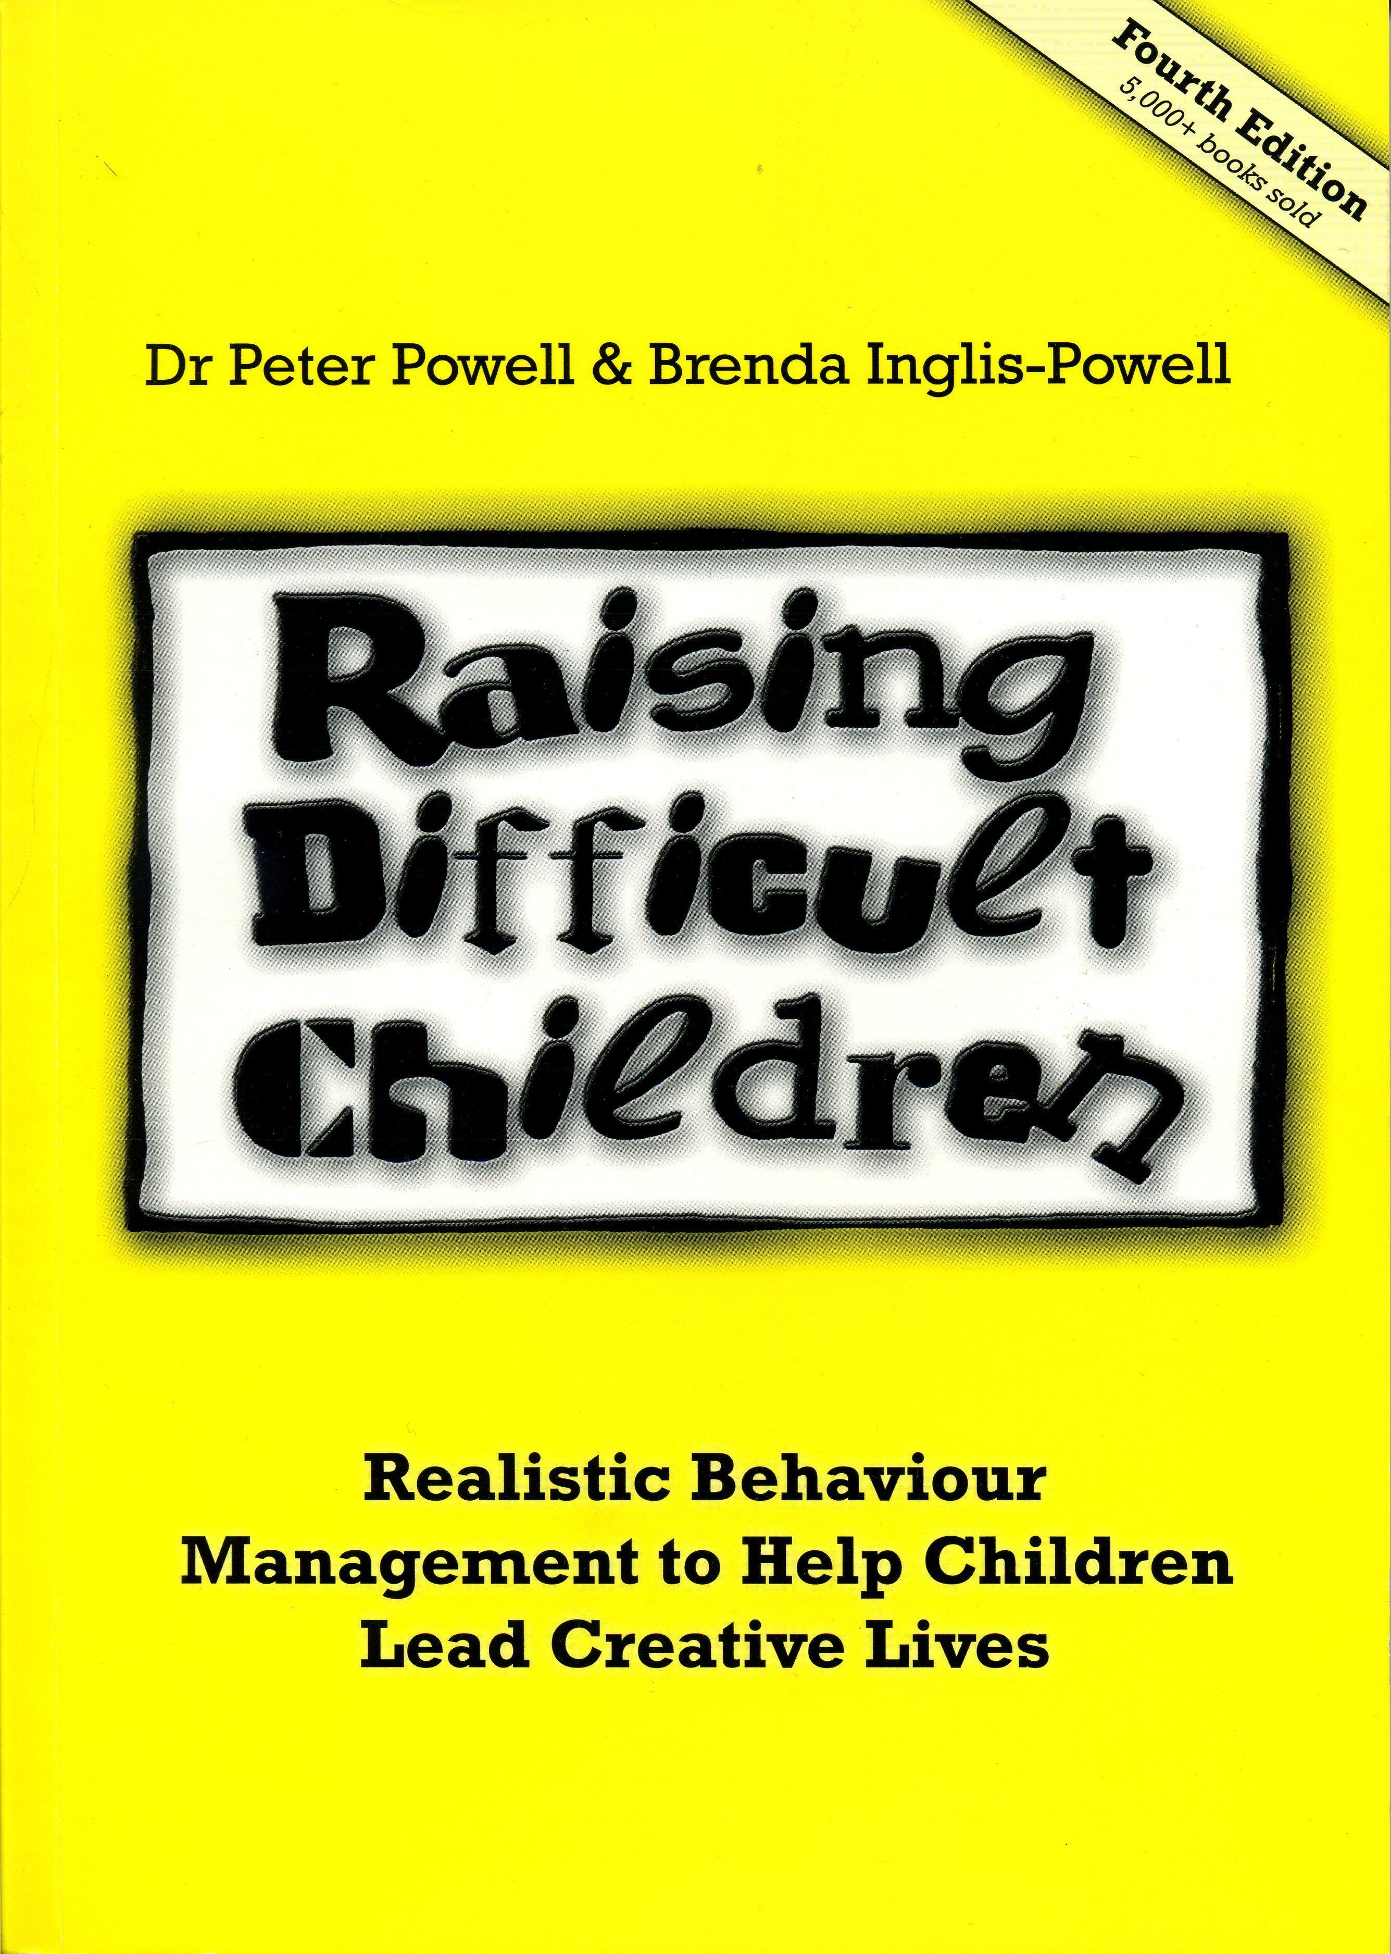

RDC BOOK
ORDER FORM

ISBN No: 978-0-646-47905-7
CONTACT DETAILS:
Title /Name:
Organisation:
Purchase Order No.:
Postal Address:
Email:
Phone Home:
Phone Work:
Phone Mobile:
Fax:
ADVERTISING FEEDBACK:
Where did you hear about the book?
PAYMENT DETAILS:
Cost: | $20 each book +  $5.00 postage & handling in Australia (Includes GST)  Postage $AU15 overseas  (if ordering more than one copy please enquire as to cost of postage)  Total $25.00 for one book posted in Australia
Quantity:
Total | $  Online Payment
Please make cheque or money order payable to
Pastoral Counselling Institute

ABN 74 694 179 299
If you wish to pay online by direct deposit, please tick 'online payment' in total,
payment details will be emailed to you
Please send this completed order form with your cheque or money order to:
Pastoral Counselling Institute
16 Masons Drive
North Parramatta NSW 2151
Book will be sent on receipt of payment,
please allow 10 working days for arrival of book.

